**KL UNIVERSITY**



**Department of Computer Science Engineering**

**Course code -15CS3113**

**PLATFORM BASED DEVELOPMENT**

**III B.Tech – 1st Semester**

**Academic Year 2018-2019**

**Project Based Lab**

**ON**

**FACULTY FEEDBACK**

**Submitted by**

**Section – 21**

**Batch No: 05**

|  |  |  |
| --- | --- | --- |
| Student ID | Student Name | Department |
| 160030231 | CH.Vijaya Lakshmi | C.S.E |
| 160031555 | P.G.Jahnavi | C.S.E |
| 160031003 | Venkat Reddy | C.S.E |

**K L UNIVERSITY**

**DEPARTMENT OF COMPUTER SCIENCE ENGINEERING**

**(DST-FIST Sponsored Department)**



**CERTIFICATE**

This is to certify that the course based project entitled **“FACULTY FEEDBACK ”** is a bonafide work done by **CH.Vijaya Lakshmi(160030231), P.G.Jahnavi(160031555), Venkata Reddy,**in partial fulfilment of the requirement for the award of degree in **BACHELOR OF TECHNOLOGY** in **Computer Science Engineering** during the academic year **2018-2019.**

**Faculty In Charge Head of the Department**

**DEPARTMENT OF COMPUTER SCIENCE ENGINEERING**

**(DST-FIST Sponsored Department)**



**DECLARATION**

We hereby declare that this project based lab report entitled **“FACULTY FEEDBACK”** has been prepared by us in partial fulfillment of the requirement for the award of degree “**BACHELOR OF TECHNOLOGY in COMPUTER SCIENCE ENGINEERING**” during the academic year 2018-2019.

We also declare that this project based lab report is of our own effort and it has not been submitted to any other university for the award of any degree.

**Date:**

|  |  |
| --- | --- |
| **NAME** | **STUDENT ID** |
| CH.VijayaLakshmi | 160030231 |
| P.G.Jahnavi | 160031555 |
| Venkata Reddy |  |

Place: Vaddeswaram

**ACKNOWLEDGMENT**

Our sincere thanks to **DR.M.S.R.Prasad** sir in the Lab for his outstanding support throughout the project for the successful completion of the work.

We express our gratitude to **DR.HARI KIRAN VEGE** Head of the Department for Computer Science and Engineering for providing us with adequate facilities, ways and means by which we are able to complete this term paper work.

We would like to place on record the deep sense of gratitude to the honourable Vice Chancellor, K L University for providing the necessary facilities to carry the concluded term paper work.

Last but not the least, we thank all Teaching and Non-Teaching Staff of our department and especially my classmates and my friends for their support in the completion of our project work.

Finally, it is pleased to acknowledge the indebtedness to all those who devoted themselves directly or indirectly to make this project report success.

**PROJECT ASSOCIATES**

|  |  |
| --- | --- |
| **Name** | **Student ID** |
| P.G.Jahnavi | 160031555 |
| CH.Vijaya Lakshmi | 160030231 |
| Venkata Reddy |  |

**INDEX**

|  |  |  |
| --- | --- | --- |
| **S.no** | **TABLE OF CONTENTS** | **Pageno** |
| 1. | ABSTRACT | 9 |
| 2. | INTRODUCTION | 10 |
| 3. | FUNCTIONAL REQUIREMENT | 12 |
| 4. | NON FUNCTIONAL REQUIREMENT | 13 |
| 5. | MODULE EXPLANATION | 14 |
| 6. | SOURCE CODE | 52 |
| 7. | OUTPUT | 55 |
| 8. | CONCLUSION | 56 |

**Introduction to technology used in this project (Android):**

Android delivers a complete set of software for mobile devices:

• Operating System

• Middleware

• Key mobile applications

• Open

• Breaking down Application Boundaries

• Fast & Easy Application Development

Industry

• Software stack opensourced under Apache 2.0 license

• Source available after first handsets ship

• Anyone will be able to build a system image

Users

• Users have control of their experience

• They control what gets installed

• They choose the defaults

Developer

• Don not need permission to ship an application

• No hidden or privileged framework APIs

• Can integrate, extend and replace existing components

**LINUX KERNEL:**

• Android OS is built on top of the Linux 2.6 Kernel

– Linux Core functionality

• Memory management

• Process management

• Networking

• Security settings

– Hardware drivers

**Android Runtime:**

What is Android? > Android Architecture

• Core Libraries

– Provides the functionality of the JAVA Programming Language

• Dalvik VM

– A type of Java Virtual Machine

– Register based (not stack machine like JVM)

– Optimization for low memory requirements

– Executes .dex (Dalvik-Executable) files instead of .class

– DX tool converts classes to .dex format Each Android application:

• runs on its own Process

• runs on its own Instance of Dalvik VM

• is assigned its own Linux user ID

**Application Framework:**

What is Android? > Android Architecture

• The blocks that our applications directly interact with.

• Important blocks: – Activity Manager: Manages the activity life cycle of applications

– Content Providers: Manage the data sharing between applications

– Telephony Manager: Manages all voice calls. We use telephony manager if we want to access voice calls in our application.

– Location Manager: Location management, using GPS or cell tower

– Resource Manager: Manage the various types of resources we use in our Application

**Applications:**

• This is where our applications are placed.

• Some pre-installed applications:

– SMS client app

– Dialer

– Web browser

– Contact manager

• As developers, we are able to write an app which replaces any existing system app.

**Details:-**

• Design goals

– Open Source

– High flexibility

– High data accessibility

– Rapid development (XML, Java)

• Used Languages

– App: Java

– Framework: Java

– Libraries: C/C++

– OS & Drivers: C

**ABSTRACT**

In order to maintain a good recognition at college, the management does every possible aspect in maintaining the qualities of the lecturer’s. As this is the online-era, where everything is online we need to develop a system in online which is very useful to maintain feedback reports by the administrator. The purpose of this project is to make the process of taking feedback from the students in online regarding the lecturer’s teaching. With this, the institutes can access the feedback reports in a faster way and without any loss of data. As of now this task was done manually with the use of papers and pens. This has many drawbacks and evaluating this hand written forms is a difficult process. Student needs to logging into the website of online feedback system and giving his/her feedback and can perform modifications too. But the restriction here is once the student submits the report then he cannot modify it later. With this the student can successfully submit feedback on lecturer’s teaching in a very efficient manner without any loss of data. The administrator and the faculty members can access these feedbacks from the students and take appropriate actions.

The main features of this project are:

1. LOGIN
2. SUBJECT SELECTION
3. STUDENT FEEDBACK

**OBJECTIVE:**

1)Decision making power is provided by this system.

2) Accurate result can be obtained.

3) This system makes Selection process more effective.

4) To increase efficiency proposed system is depend on classification method.

5) Proposed system is used to reduce confusion at the time of processing feedback.

**INTRODUCTION**

Online student feedback system is the web based feedback collecting system from the students and provides the automatic generation of a feedback which is given by students. We have developed student feedback system to provide feedback in a quick and easy manner to the particular department. We have developed Student Staff Feedback System to provide feedback in an easy and quick manner to the college principal and Hod’s. So we call it as Student Staff Feedback System which delivers via the student staff interface as online system which acting as a Service Provider. So we called it a student’s feedback system which delivers via the student staff interface as online system which acting as a service provider. By using this technology we can make fast feedback about the staff by students on time to head of departments as they referred in online system. By using this technology we can give feedback in online system as fast as compare to the existing paper feedback system.

This project has four kinds of users Student, Staff, Hod’s, and Principal. The student can give feedback in online system provided by college staff. The existing system carries more time to do a piece of work for this reason the online system feedback is implemented. First of staff can prepare questions & add, update these questions to the online system.

After that it was viewed by the students and can give feedback about the lecturers.Students will fill online feedback using a standard form. In this project security is also maintain that is the result of feedback is only visible to authentic user. This feedback report was checked by the Hod’s. He can view grades and view the grades obtained to the lecturers and give this report to the principal and he give counseling to the college staff

.

**MODULES OF STUDENT FEEDBACK MANAGEMENT SYSTEM**  
  
The proposed system consists of four modules:  
**Student :**  
Student can give the feedback about the lecturers on the scale of five. Students can give feed back about the lecturer based on interaction of lecturer in the class room with students. Here we shared complete list of student projects that we shared in this page. Screenshot of Employee and Payroll System; Project SRS.IEEE Standard SRS. According to that, students can give feedback as per the given grades.  
**Staff:**  
The feedback given by the students can be viewed by the staff and improve their performance in teaching and other aspects

**Head Of Departments :**  
These feedback reports were checked by the Hod’s. He can view overall grades and view the grades obtained to the lecturers and give this report to the principal and he can give counseling to the college staff  
**Principal :**

Finally, report was referred by the principal and give suggestions to lecturers to improve their teaching. These are the four modules present in the project so we have developed these things in very easy and clearly understandable way. So, by seen above description the proposed system having many advantages as compared to the existing system.

**PLATFORM REQUIREMENTS:**

|  |  |  |
| --- | --- | --- |
| **Hardware/Software** | **Hardware / Software element** | **Specification /version** |
| **Hardware** | Processor | Intel multi-core i5 |
| RAM | 4 GB |
| Hard Disk | 1 TB |
| **Software** | OS | Windows 10 |
| Java Command Prompt and Notepad |  |

**SOFTWARE REQUIREMENTS SPECIFICATION:**

|  |  |
| --- | --- |
| **Serial Number** | **Name of the Module** |
|  | LOGIN |
|  | SUBJECT SELECTION |
|  | STUDENT FEEDBACK |
|  | FACULTY |

**NON FUNCTIONAL REQUIREMENTS:**

**EXCEPTION HANDLING:**

An exception (or exceptional event) is a problem that arises during the execution of a program.When an Exception occurs the normal flow of the program is disrupted and the program/Application terminates abnormally, which is not recommended, therefore,these exceptions are to be handled.

**BUFFERED READER:**

The Java.io.BufferedReader class reads text from a character-input stream, buffering characters so as to provide for the efficient reading of characters, arrays, and lines.Following are the important points about BufferedReader − The buffer size may be specified, or the default size may be used.

**FILE READER:**

The FileReader object lets web applications asynchronously read the contents of files (or raw data buffers) stored on the user's computer, using File or Blob objects to specify the file or data to read.

**FILE WRITTER:**

Java File Writer class is used to write character-oriented data to a file. It is character-oriented class which is used for file handling in java. Unlike FileInputStream class, you don't need to convert string into byte array because it provides method to write string directly.

**FORMATTER:**

The **java.util.Formatter** class provides support for layout justification and alignment, common formats for numeric, string, and date/time data, and locale-specific output.Following are the important points about Formatter:

Formatters are not necessarily safe for multithreaded access.Thread safety is optional and is the responsibility of users of methods in this class.

**STATIC KEYWORD:**

All instances share the same copy of the variable. A class variable can be accessed directly with the class, without the need to create a instance.

MODULEDESCRIPTION

**MODULE 1:**

Here we will be creating database with the help of MyDBHelper class for faculty feedback with login design in main activity containing details like User id and password. Here each and every record has to be entered manually through keyboard, where it asks the user to login or reset your user id and password he need to enter. After entering those details through proper format those details which user gives can be saved**.** In this module we will be able to give feedback of the student as well as faculty, where details will be in the form of web page used to fill the given form Here in this module database takes control of all the things for searching the complete details of faculty or student. Here in generating feedback we will be able to display all the details of student or faculty which will be stored in the database.

**MODULE 2:**

Here in this module we will have activities for student feedback.After user(student) login with the details provided in main activity after that it will ask to fill the feeback like image containing activity called image after that another activity called login activity this will ask the conditions or rules to agree after that another activity called subject selection in this we have to select any one of the subject and fill the respective subject feedback form after filling feedback of all the subjects provided please click on submit after submiting it will display your feedback is saved which is done in another activity.one more thing for each subject there will be separate activity.With help of these activities student feedback form will be completed successfully

**MODULE 3:**

Here in this module we will have activities for faculty feedback.As like student feedback after user(faculty)login login with the details provided in main activity after that it will ask to fill the feeback like image containing activity called image after that the id who are logged in his/her name with the name as well as section his/her was teaching along with his/her id will be displayed that is contained in another activity.Another activity will give the details how many students submitted feedbackforms of his/her respective subjects along with percentage will be displayed. With help of these activities faculty feedback form will be completed successfully

SOURCE CODE:

**MODULE 1:**

File:MainActivity.java

**package** com.example.facultyfeedback;  
  
**import** android.content.Intent;  
**import** android.os.Bundle;  
**import** android.support.v7.app.AppCompatActivity;  
**import** android.view.MenuItem;  
**import** android.view.View;  
**import** android.widget.EditText;  
**import** android.widget.Toast;  
  
  
  
**public class** MainActivity **extends** AppCompatActivity {  
 EditText **txt1**;  
 EditText **txt2**;  
 MyDBHelper **myDBHelper**;  
@Override  
**protected void** onCreate(Bundle savedInstanceState) {  
**super**.onCreate(savedInstanceState);  
 setContentView(R.layout.***activity_main***);  
**txt1**=findViewById(R.id.***editText***);  
**txt2**=findViewById(R.id.***editText2***);  
**myDBHelper** = **new** MyDBHelper(**this**);  
**myDBHelper**.insertstudentrec(**"CSE"**,**"B.Tech"**,**"Y16"**,**"2"**,**"EVEN"**,8,160030001,**"Akhila"**,**"klef30001"**);  
**myDBHelper**.insertstudentrec(**"CSE"**,**"B.Tech"**,**"Y16"**,**"2"**,**"EVEN"**,8,160030002,**"Alekya"**,**"klef30002"**);  
**myDBHelper**.insertstudentrec(**"CSE"**,**"B.Tech"**,**"Y16"**,**"2"**,**"EVEN"**,8,160030003,**"Akarsh"**,**"klef30003"**);  
**myDBHelper**.insertstudentrec(**"CSE"**,**"B.Tech"**,**"Y16"**,**"2"**,**"EVEN"**,8,160030004,**"Akansha"**,**"klef30004"**);  
**myDBHelper**.insertstudentrec(**"CSE"**,**"B.Tech"**,**"Y16"**,**"2"**,**"EVEN"**,8,160030005,**"Alice"**,**"klef30005"**);  
**myDBHelper**.insertstudentrec(**"CSE"**,**"B.Tech"**,**"Y16"**,**"2"**,**"EVEN"**,8,160030006,**"Bob"**,**"klef30006"**);  
**myDBHelper**.insertstudentrec(**"CSE"**,**"B.Tech"**,**"Y16"**,**"2"**,**"EVEN"**,8,160030007,**"Cheran"**,**"klef30007"**);  
**myDBHelper**.insertstudentrec(**"CSE"**,**"B.Tech"**,**"Y16"**,**"2"**,**"EVEN"**,8,160030008,**"Dhawan"**,**"klef30008"**);  
**myDBHelper**.insertstudentrec(**"CSE"**,**"B.Tech"**,**"Y16"**,**"2"**,**"EVEN"**,8,160030009,**"Ekkirala"**,**"klef30009"**);  
**myDBHelper**.insertstudentrec(**"CSE"**,**"B.Tech"**,**"Y16"**,**"2"**,**"EVEN"**,8,160030010,**"Fareeha"**,**"klef30010"**);  
**myDBHelper**.insertstudentrec(**"CSE"**,**"B.Tech"**,**"Y16"**,**"2"**,**"EVEN"**,8,160030011,**"Hanisha"**,**"klef30011"**);  
**myDBHelper**.insertstudentrec(**"CSE"**,**"B.Tech"**,**"Y16"**,**"2"**,**"EVEN"**,8,160030012,**"Hareendra"**,**"klef30012"**);  
**myDBHelper**.insertstudentrec(**"CSE"**,**"B.Tech"**,**"Y16"**,**"2"**,**"EVEN"**,8,160030013,**"Ijaz"**,**"klef30013"**);  
**myDBHelper**.insertstudentrec(**"CSE"**,**"B.Tech"**,**"Y16"**,**"2"**,**"EVEN"**,8,160030014,**"Jasmine"**,**"klef30014"**);  
**myDBHelper**.insertstudentrec(**"CSE"**,**"B.Tech"**,**"Y16"**,**"2"**,**"EVEN"**,8,160030015,**"Kohli"**,**"klef30015"**);  
**myDBHelper**.insertstudentrec(**"CSE"**,**"B.Tech"**,**"Y16"**,**"2"**,**"EVEN"**,8,160030016,**"Lucky"**,**"klef30016"**);  
**myDBHelper**.insertstudentrec(**"CSE"**,**"B.Tech"**,**"Y16"**,**"2"**,**"EVEN"**,8,160030017,**"Mahathalli"**,**"klef30017"**);  
**myDBHelper**.insertstudentrec(**"CSE"**,**"B.Tech"**,**"Y16"**,**"2"**,**"EVEN"**,8,160030018,**"Nick Jones"**,**"klef30018"**);  
**myDBHelper**.insertstudentrec(**"CSE"**,**"B.Tech"**,**"Y16"**,**"2"**,**"EVEN"**,8,160030019,**"Prathima"**,**"klef30019"**);  
**myDBHelper**.insertstudentrec(**"CSE"**,**"B.Tech"**,**"Y16"**,**"2"**,**"EVEN"**,8,160030020,**"Subbalakshmi"**,**"klef30020"**);  
**myDBHelper**.insertfacultyrec(**"CSE"**,**"M.TECH"**,**"PBD"**,**"2"**,**"EVEN"**,8,30029,**"KRISHNA"**,**"klef30029"**,0,0);  
**myDBHelper**.insertfacultyrec(**"CSE"**,**"M.TECH"**,**"ADA"**,**"2"**,**"EVEN"**,8,30769,**"DO-MIN-JOON"**,**"klef30769"**,0,0);  
**myDBHelper**.insertfacultyrec(**"CSE"**,**"M.TECH"**,**"OS"**,**"2"**,**"EVEN"**,8,31415,**"CHEONG-SONG-YI"**,**"klef31415"**,0,0);  
 getSupportActionBar().setDisplayHomeAsUpEnabled(**true**);  
  
 }  
**public boolean** onOptionsItemSelected(MenuItem item) {  
**switch**(item.getItemId()){  
**case** android.R.id.***home***:  
 Intent i=**new** Intent(MainActivity.**this**,image.**class**);  
 startActivity(i);  
**return true**;  
**default**:  
**return super**.onOptionsItemSelected(item);  
  
 }  
  
 }  
  
**public void** reset(View view) {  
**txt2**.setText(**""**);  
**txt1**.setText(**""**);  
 }  
  
**public void** login(View view) {  
 String uid = **txt1**.getText().toString();  
 String pwd = **txt2**.getText().toString();  
**if** (uid.length() == 0 && pwd.length() == 0) {  
**txt1**.setError(**"Enter Username"**);  
**txt2**.setError(**"Enter Password"**);  
 } **else if** (uid.length() == 0) {  
**txt1**.setError(**"Enter Username"**);  
 } **else if** (pwd.length() == 0) {  
**txt2**.setError(**"Enter Password"**);  
 } **else** {  
**try** {  
**int** sid = Integer.*parseInt*(uid);  
 String msg = **myDBHelper**.checkLogin(sid, pwd);  
  
**if** (msg.equals(**"success"**)) {  
  
 Intent i = **new** Intent(MainActivity.**this**, image.**class**);  
 DemoClass.*message*=uid.toString();  
 Bundle b = **new** Bundle();  
 b.putString(**"id"**, uid);  
 i.putExtras(b);  
 startActivity(i);  
 } **else if** (msg.equals(**"facultysuccess"**)) {  
  
 Intent t = **new** Intent(MainActivity.**this**, FacultyImage.**class**);  
 Bundle b = **new** Bundle();  
 b.putString(**"id"**, uid);  
 DemoClass.*message1*=uid.toString();  
 t.putExtras(b);  
 startActivity(t);  
 } **else** {  
 Toast.*makeText*(getApplicationContext(), **"Invalid Login"**, Toast.***LENGTH_LONG***).show();  
**txt1**.setText(**""**);  
**txt2**.setText(**""**);  
  
 }  
 } **catch** (Exception e) {  
 Toast.*makeText*(getApplicationContext(), **"Invalid Login"**, Toast.***LENGTH_LONG***).show();  
**txt1**.setText(**""**);  
**txt2**.setText(**""**);  
 }  
  
  
 }  
  
 }  
  
  
  
}

FiLe:activity_main.xml

*<?***xml version="1.0" encoding="utf-8"***?>*<**android.support.constraint.ConstraintLayout xmlns:android="http://schemas.android.com/apk/res/android"  
xmlns:app="http://schemas.android.com/apk/res-auto"  
xmlns:tools="http://schemas.android.com/tools"  
android:layout_width="match_parent"  
android:background="@drawable/bg"  
android:layout_height="match_parent"  
tools:context=".MainActivity"**>  
  
<**EditText  
android:id="@+id/editText"  
android:layout_width="wrap_content"  
android:layout_height="wrap_content"  
android:layout_marginTop="152dp"  
android:ems="10"  
android:hint="User ID"  
android:inputType="textPersonName"  
app:layout_constraintEnd_toEndOf="parent"  
app:layout_constraintHorizontal_bias="0.502"  
app:layout_constraintStart_toStartOf="parent"  
app:layout_constraintTop_toTopOf="parent"** />  
  
<**EditText  
android:id="@+id/editText2"  
android:layout_width="wrap_content"  
android:layout_height="wrap_content"  
android:layout_marginTop="220dp"  
android:ems="10"  
android:hint=" Password"  
android:inputType="textPassword"  
app:layout_constraintEnd_toEndOf="parent"  
app:layout_constraintHorizontal_bias="0.502"  
app:layout_constraintStart_toStartOf="parent"  
app:layout_constraintTop_toTopOf="parent"** />  
  
<**Button  
android:id="@+id/button"  
android:layout_width="70dp"  
android:layout_height="50dp"  
android:layout_marginStart="80dp"  
android:layout_marginTop="300dp"  
android:text="Login"  
app:layout_constraintStart_toStartOf="parent"  
app:layout_constraintTop_toTopOf="parent"  
android:onClick="login"**/>  
  
<**Button  
android:id="@+id/button2"  
android:layout_width="70dp"  
android:layout_height="50dp"  
android:layout_marginEnd="80dp"  
android:layout_marginTop="300dp"  
android:text="Reset"  
app:layout_constraintEnd_toEndOf="parent"  
app:layout_constraintTop_toTopOf="parent"  
android:onClick="reset"**/>  
  
<**ImageView  
android:id="@+id/imageView"  
android:layout_width="360dp"  
android:layout_height="130dp"  
android:background="@drawable/bg"  
app:srcCompat="@drawable/klulogo"  
tools:ignore="MissingConstraints"  
tools:layout_editor_absoluteX="0dp"  
tools:layout_editor_absoluteY="0dp"** />  
  
</**android.support.constraint.ConstraintLayout**>

Mydbhelper.java

**package** com.example.facultyfeedback;  
  
**import** android.content.ContentValues;  
**import** android.content.Context;  
**import** android.database.Cursor;  
**import** android.database.sqlite.SQLiteDatabase;  
**import** android.database.sqlite.SQLiteOpenHelper;  
**import** android.widget.Toast;  
  
**public class** MyDBHelper**extends** SQLiteOpenHelper {  
 SQLiteDatabase **db**;  
**private static final int *DATABASE_VERSION*** = 1;  
**private static final** String ***DATABASE_NAME*** = **"feedbackdb"**;  
**private static final** String ***TABLE_NAME*** = **"student"**;  
**private static final** String ***TABLE_NAME1*** = **"faculty"**;  
 Context **context**;  
  
**public** MyDBHelper(Context context) {  
**super**(context, ***DATABASE_NAME***, **null**, ***DATABASE_VERSION***);  
**this**.**context** = context;  
  
 }  
  
@Override  
**public void** onCreate(SQLiteDatabase db) {  
 String qry = **"CREATE TABLE "** + ***TABLE_NAME*** + **" (department varchar(10) not null,program varchar(10) not null,batch varchar(10) not null,year varchar(10) not null,semester varchar(10) not null,section int not null,id int primary key,name varchar(50) not null,password varchar(20) not null)"**;  
 db.execSQL(qry);  
 String qry1 = **"CREATE TABLE "** + ***TABLE_NAME1*** + **" (department varchar(10) not null,designation varchar(10) not null,subject varchar(10) not null,year varchar(10) not null,semester varchar(10) not null,section int not null,id int not null,name varchar(20) not null,password varchar(10) not null,totalpoints int not null,numberofstudents int not null)"**;  
 db.execSQL(qry1);  
  
 }  
  
@Override  
**public void** onUpgrade(SQLiteDatabase db, **int** oldVersion, **int** newVersion) {  
 String qry = **"DROP TABLE "** + ***TABLE_NAME*** + **""**;  
  
 String qry1 = **"DROP TABLE "** + ***TABLE_NAME1*** + **""**;  
 onCreate(db);  
 }  
  
**public void** insertstudentrec(String dept, String program, String batch, String year, String sem,**int** sec, **int** id, String name, String password) {  
**try** {  
**db** = getWritableDatabase();  
  
 ContentValues cv = **new** ContentValues();  
 cv.put(**"department"**, dept);  
 cv.put(**"program"**, program);  
 cv.put(**"batch"**, batch);  
 cv.put(**"year"**, year);  
 cv.put(**"semester"**, sem);  
 cv.put(**"section"**,sec);  
 cv.put(**"id"**, id);  
 cv.put(**"name"**, name);  
 cv.put(**"password"**, password);  
  
**db**.insert(***TABLE_NAME***, **null**, cv);  
  
  
 } **catch** (Exception e) {  
 Toast.*makeText*(**context**, e.getMessage(), Toast.***LENGTH_LONG***).show();  
 }  
 }  
**public void** insertfacultyrec(String dept, String desg, String sub, String year, String sem,**int** sec, **int** id, String name, String password,**int** totpoints,**int** noofstudents) {  
**try** {  
**db** = getWritableDatabase();  
  
 ContentValues cv = **new** ContentValues();  
 cv.put(**"department"**, dept);  
 cv.put(**"designation"**, desg);  
 cv.put(**"subject"**, sub);  
 cv.put(**"year"**, year);  
 cv.put(**"semester"**, sem);  
 cv.put(**"section"**,sec);  
 cv.put(**"id"**, id);  
 cv.put(**"name"**, name);  
 cv.put(**"password"**, password);  
 cv.put(**"totalpoints"**,totpoints);  
 cv.put(**"numberofstudents"**,noofstudents);  
  
**db**.insert(***TABLE_NAME1***, **null**, cv);  
  
  
 } **catch** (Exception e) {  
 Toast.*makeText*(**context**, e.getMessage(), Toast.***LENGTH_LONG***).show();  
 }  
 }  
  
  
**public** String checkLogin(**int** id, String password) {  
 String msg = **null**;  
  
**try** {  
**db** = getWritableDatabase();  
 Cursor cursor = **db**.rawQuery(**"select * from student where id="** + id + **" and password='"** + password + **"'"**, **null**);  
 Cursor cursor1=**db**.rawQuery(**"select * from faculty where id="** + id + **" and password='"** + password + **"'"**, **null**);  
**if** (cursor.moveToNext()) {  
 msg = **"success"**;  
 }  
**else if**(cursor1.moveToNext())  
 {  
 msg=**"facultysuccess"**;  
 }  
  
**else** {  
 msg = **"fail"**;  
 }  
 } **catch** (Exception e) {  
 Toast.*makeText*(**context**, e.getMessage(), Toast.***LENGTH_LONG***).show();  
 }  
  
**return** msg;  
 }  
  
**public** String getname(**int** i) {  
 String nm=**""** ;*//= "Hi";***try** {  
**db** = getWritableDatabase();  
  
  
 Cursor c = **db**.rawQuery(**"select name from "**+***TABLE_NAME***+**" where id=?"**,**new** String[]{String.*valueOf*(i)});  
*//Cursor c=db.rawQuery(String.format("Select name from %s where id=?", TABLE_NAME),new String[]{String.valueOf(i)});***while** (c.moveToNext()) {  
 nm = c.getString(0);  
 }  
  
 }  
**catch** (Exception e)  
 {  
 Toast.*makeText*(**context**,e.getMessage(),Toast.***LENGTH_LONG***).show();  
 }  
**return** nm;  
 }  
  
*/* public int getsection(int p) {  
 Integer sc=0;//= "Hi";  
 try {  
 db = getWritableDatabase();  
  
  
 Cursor c1 = db.rawQuery("select section from "+TABLE_NAME+" where id=?",new String[]{String.valueOf(p)});  
 //Cursor c=db.rawQuery(String.format("Select name from %s where id=?", TABLE_NAME),new String[]{String.valueOf(i)});  
  
  
 while (c1.moveToNext()) {  
 sc = c1.getInt(0);  
 }  
  
 }  
 catch (Exception e)  
 {  
 Toast.makeText(context,e.getMessage(),Toast.LENGTH_LONG).show();  
 }  
 return sc;  
 }  
/*public String name(int id)  
{  
 db=getWritableDatabase();  
 db.rawQuery("select name from student where id=" + id, null);  
}*/*}

**MODULE 2:**

Image.java

**package** com.example.facultyfeedback;  
  
**import** android.content.Intent;  
**import** android.support.v7.app.AppCompatActivity;  
**import** android.os.Bundle;  
**import** android.view.MenuItem;  
**import** android.view.View;  
  
**public class** image **extends** AppCompatActivity {  
  
@Override  
**protected void** onCreate(Bundle savedInstanceState) {  
**super**.onCreate(savedInstanceState);  
 setContentView(R.layout.***activity_image***);  
 getSupportActionBar().setDisplayHomeAsUpEnabled(**true**);  
  
 }  
**public boolean** onOptionsItemSelected(MenuItem item) {  
**switch**(item.getItemId()){  
**case** android.R.id.***home***:  
 Intent i=**new** Intent(image.**this**,LoginActivity.**class**);  
 startActivity(i);  
**return true**;  
**default**:  
**return super**.onOptionsItemSelected(item);  
  
 }  
  
 }  
  
  
**public void** image(View view) {  
 Intent i=**new** Intent(image.**this**,LoginActivity.**class**);  
 startActivity(i);  
 }  
}

*<?***xml version="1.0" encoding="utf-8"***?>*<**RelativeLayout xmlns:android="http://schemas.android.com/apk/res/android"  
xmlns:app="http://schemas.android.com/apk/res-auto"  
xmlns:tools="http://schemas.android.com/tools"  
android:layout_width="match_parent"  
  
android:layout_height="match_parent"  
tools:context="com.example.facultyfeedback.image"**>  
  
<**ImageView  
android:id="@+id/imageView3"  
android:layout_width="wrap_content"  
android:layout_height="507dp"  
app:srcCompat="@drawable/w"  
android:onClick="image"  
tools:layout_editor_absoluteX="0dp"  
tools:layout_editor_absoluteY="3dp"** />  
</**RelativeLayout**>

loginActivity.java

**package** com.example.facultyfeedback;  
  
**import** android.content.Intent;  
**import** android.support.v7.app.AppCompatActivity;  
**import** android.os.Bundle;  
**import** android.view.MenuItem;  
**import** android.view.View;  
  
**public class** LoginActivity**extends** AppCompatActivity {  
  
@Override  
**protected void** onCreate(Bundle savedInstanceState) {  
**super**.onCreate(savedInstanceState);  
 setContentView(R.layout.***activity_login***);  
 getSupportActionBar().setDisplayHomeAsUpEnabled(**true**);  
  
 }  
**public boolean** onOptionsItemSelected(MenuItem item) {  
**switch**(item.getItemId()){  
**case** android.R.id.***home***:  
 Intent i=**new** Intent(LoginActivity.**this**,SubjectSelection.**class**);  
 startActivity(i);  
**return true**;  
**default**:  
**return super**.onOptionsItemSelected(item);  
  
 }  
  
 }  
  
**public void** agree(View view) {  
 Intent i=**new** Intent(LoginActivity.**this**,SubjectSelection.**class**);  
 startActivity(i);  
  
 }  
}

*<?***xml version="1.0" encoding="utf-8"***?>*<**RelativeLayout xmlns:android="http://schemas.android.com/apk/res/android"  
xmlns:app="http://schemas.android.com/apk/res-auto"  
xmlns:tools="http://schemas.android.com/tools"  
android:id="@+id/container"  
android:layout_width="match_parent"  
android:layout_height="match_parent"  
android:background="@drawable/t"  
tools:context="com.example.facultyfeedback.LoginActivity"**>  
  
  
<**TextView  
android:id="@+id/textView4"  
android:layout_width="match_parent"  
android:layout_height="wrap_content"  
android:layout_alignParentStart="true"  
android:layout_alignParentTop="true"  
android:layout_marginTop="14dp"  
android:fontFamily="cursive"  
android:text=" Feedback on Teaching "  
android:textColor="@android:color/background_dark"  
android:textSize="30sp"** />  
  
<**TextView  
android:id="@+id/textView2"  
android:layout_width="wrap_content"  
android:layout_height="wrap_content"  
android:layout_below="@+id/textView4"  
android:layout_centerHorizontal="true"  
android:layout_marginTop="34dp"  
android:fontFamily="cursive"  
android:text=" Dear Students, We at KL University wish to take your feedback on the teaching process in the courses being conducted in the current semester. Please note that it is important to provide constructive feedback so that we can use this as an opportunity to improvise your learning experience at KLU. Please note that each question must be read carefully and an unbiased feedback must be provided so that effective measures can be adopted to improvise the teaching quality in your courses. I agree that I have read and understood the importance of providing constructive and unbiased feedback."  
android:textColor="?attr/colorPrimaryDark"  
android:textSize="20sp"** />  
  
<**RadioButton  
android:id="@+id/radioButton"  
android:layout_width="wrap_content"  
android:layout_height="wrap_content"  
android:layout_alignParentStart="true"  
android:onClick="agree"  
android:layout_below="@+id/textView2"  
android:layout_marginTop="19dp"  
android:text="I Agree"** />  
  
</**RelativeLayout**>

SubjectSelection.java

**package** com.example.facultyfeedback;  
  
**import** android.content.Intent;  
**import** android.database.Cursor;  
**import** android.database.sqlite.SQLiteDatabase;  
**import** android.support.v7.app.AppCompatActivity;  
**import** android.os.Bundle;  
**import** android.view.View;  
**import** android.widget.AdapterView;  
**import** android.widget.ArrayAdapter;  
**import** android.widget.Spinner;  
**import** android.widget.TextView;  
  
  
**public class** SubjectSelection **extends** AppCompatActivity **implements** AdapterView.OnItemSelectedListener {  
 TextView **txt2**,**txt1**,**txt3**;  
 Spinner **spinner**;  
 ArrayAdapter **arrayAdapter**;  
 String **name**;  
 MyDBHelper **myDBHelper**;  
 Integer **section**;  
 SQLiteDatabase **db**;  
  
 String **sc**;  
  
 String **course**[]={**"--select Subject--"**,**"PBD"**,**"ADA"**,**"OS"**};  
@Override  
**protected void** onCreate(Bundle savedInstanceState) {  
**super**.onCreate(savedInstanceState);  
 setContentView(R.layout.***activity_subject_selection***);  
**myDBHelper**=**new** MyDBHelper(**this**);  
**spinner**=findViewById(R.id.***spinner***);  
**spinner**.setOnItemSelectedListener(**this**);  
**txt2**=findViewById(R.id.***textView8***);  
**txt1**=findViewById(R.id.***textView6***);  
**txt3**=findViewById(R.id.***textView10***);  
**arrayAdapter**=**new** ArrayAdapter<String >(**this**,android.R.layout.***simple_spinner_item***,**course**);  
**arrayAdapter**.setDropDownViewResource(android.R.layout.***simple_dropdown_item_1line***);  
**spinner**.setAdapter(**arrayAdapter**);  
**txt2**.setText(DemoClass.*message*);  
**name**=**myDBHelper**.getname(Integer.*parseInt*(DemoClass.*message*));  
**txt1**.setText(**name**);  
  
**db** = **myDBHelper**.getWritableDatabase();  
  
  
  
 Cursor c1 = **db**.rawQuery(**"select section from student where id=?"**,**new** String[]{String.*valueOf*(DemoClass.*message*)});  
  
**if** (c1.moveToNext())  
 {  
**sc** = c1.getString(0);  
 }  
  
**txt3**.setText(**sc**);  
  
  
 }  
  
@Override  
**public void** onItemSelected(AdapterView<?> adapterView, View view, **int** i, **long** l) {  
 String value=adapterView.getItemAtPosition(i).toString();  
  
**if**(adapterView.getItemAtPosition(i).equals(**"--select Subject--"**))  
 {  
**return**;  
  
 }  
**else if**(adapterView.getItemAtPosition(i).equals(**"PBD"**))  
 {  
 Intent y=**new** Intent(SubjectSelection.**this**,Student.**class**);  
 startActivity(y);  
 }  
**else if**(adapterView.getItemAtPosition(i).equals(**"ADA"**))  
 {  
 Intent c=**new** Intent(SubjectSelection.**this**,Ada.**class**);  
 startActivity(c);  
 }  
**else if**(adapterView.getItemAtPosition(i).equals(**"OS"**))  
 {  
 Intent c=**new** Intent(SubjectSelection.**this**,Os.**class**);  
 startActivity(c);  
 }  
  
  
 }  
  
@Override  
**public void** onNothingSelected(AdapterView<?> adapterView) {  
  
 }  
}

*<?***xml version="1.0" encoding="utf-8"***?>*<**RelativeLayout xmlns:android="http://schemas.android.com/apk/res/android"  
xmlns:app="http://schemas.android.com/apk/res-auto"  
xmlns:tools="http://schemas.android.com/tools"  
android:layout_width="match_parent"  
android:layout_height="match_parent"  
android:background="@drawable/b"  
tools:context="com.example.facultyfeedback.SubjectSelection"**>  
  
<**Spinner  
android:id="@+id/spinner"  
android:layout_width="170dp"  
android:layout_height="wrap_content"  
android:layout_below="@+id/textView7"  
android:layout_marginStart="28dp"  
android:layout_marginTop="106dp"  
android:layout_toEndOf="@+id/textView5"** />  
  
<**TextView  
android:id="@+id/textView"  
android:layout_width="wrap_content"  
android:layout_height="wrap_content"  
android:layout_alignParentTop="true"  
android:layout_alignStart="@+id/textView7"  
android:layout_marginTop="51dp"  
android:fontFamily="serif"  
android:text="Name"  
android:textColor="@color/colorAccent"  
android:textSize="24sp"** />  
  
<**ImageView  
android:id="@+id/imageView2"  
android:layout_width="wrap_content"  
android:layout_height="wrap_content"  
android:layout_alignParentStart="true"  
android:layout_below="@+id/textView5"  
android:layout_marginTop="23dp"  
app:srcCompat="@drawable/k"** />  
  
<**TextView  
android:id="@+id/textView5"  
android:layout_width="wrap_content"  
android:layout_height="wrap_content"  
android:layout_alignStart="@+id/textView7"  
android:layout_alignTop="@+id/spinner"  
android:text="SELECT COURSE"  
android:textSize="24sp"** />  
  
<**TextView  
android:id="@+id/textView6"  
android:layout_width="wrap_content"  
android:layout_height="wrap_content"  
android:layout_alignBaseline="@+id/textView"  
android:layout_alignBottom="@+id/textView"  
android:layout_alignStart="@+id/textView8"  
android:text="TextView"  
android:textSize="24sp"** />  
  
<**TextView  
android:id="@+id/textView7"  
android:layout_width="wrap_content"  
android:layout_height="wrap_content"  
android:layout_alignParentStart="true"  
android:layout_below="@+id/textView6"  
android:layout_marginStart="47dp"  
android:layout_marginTop="32dp"  
android:text="ID"  
android:textSize="24sp"** />  
  
<**TextView  
android:id="@+id/textView8"  
android:layout_width="wrap_content"  
android:layout_height="wrap_content"  
android:layout_above="@+id/textView9"  
android:layout_marginStart="61dp"  
android:layout_toEndOf="@+id/textView9"  
android:text="TextView"  
android:textSize="24sp"** />  
  
<**TextView  
android:id="@+id/textView9"  
android:layout_width="wrap_content"  
android:layout_height="wrap_content"  
android:layout_alignStart="@+id/textView5"  
android:layout_below="@+id/textView7"  
android:layout_marginTop="33dp"  
android:text="SECTION"  
android:textSize="24sp"** />  
  
<**TextView  
android:id="@+id/textView10"  
android:layout_width="wrap_content"  
android:layout_height="wrap_content"  
android:layout_alignBottom="@+id/textView9"  
android:layout_alignStart="@+id/textView8"  
android:text="TextView"  
android:textSize="24sp"** />  
</**RelativeLayout**>

Student.java

**package** com.example.facultyfeedback;  
  
**import** android.content.ContentValues;  
**import** android.content.Intent;  
**import** android.database.Cursor;  
**import** android.database.sqlite.SQLiteDatabase;  
**import** android.support.v7.app.AppCompatActivity;  
**import** android.os.Bundle;  
**import** android.view.View;  
**import** android.widget.RadioButton;  
**import** android.widget.Toast;  
  
**public class** Student **extends** AppCompatActivity {  
 Integer **t**,**p**,**q**,**r**,**s**,**tp**,**ns**;  
 String **str**;  
MyDBHelper **myDBHelper**;  
SQLiteDatabase **db**;  
@Override  
**protected void** onCreate(Bundle savedInstanceState) {  
**super**.onCreate(savedInstanceState);  
 setContentView(R.layout.***activity_student***);  
**myDBHelper**=**new** MyDBHelper(**this**);  
 }  
**public void** onRadioButtonClicked(View view) {  
**boolean** checked=((RadioButton)view).isChecked();  
  
**switch** (view.getId()) {  
**case** R.id.***question1***:  
**if** (checked) {  
**str** = **"Excellent"**;  
**t** = 1;  
  
 }  
**break**;  
**case** R.id.***question2***:  
**if** (checked) {  
**str** = **"Good"**;  
**t** = 1;  
 }  
**break**;  
**case** R.id.***question3***:  
**if** (checked) {  
**str** = **"Satisfactory"**;  
**t** = 0;  
 }  
  
**break**;  
**case** R.id.***question4***:  
**if** (checked) {  
**str** = **"UnSatisfactory"**;  
**t** = 0;  
 }  
**break**;  
  
**case** R.id.***question5***:  
**if** (checked) **str** = **"Excellent"**;  
**q**=1;  
**break**;  
**case** R.id.***question6***:  
**if** (checked) **str** = **"Good"**;  
**q**=1;  
**break**;  
**case** R.id.***question7***:  
**if** (checked) **str** = **"Satisfactory"**;  
**q**=0;  
**break**;  
**case** R.id.***question8***:  
**if** (checked) **str** = **"UnSatisfactory"**;  
**q**=0;  
**break**;  
**case** R.id.***question9***:  
**if** (checked) **str** = **"Excellent"**;  
**r**=1;  
**break**;  
**case** R.id.***question10***:  
**if** (checked) **str** = **"Good"**;  
**r**=1;  
**break**;  
**case** R.id.***question11***:  
**if** (checked) **str** = **"Satisfactory"**;  
**r**=0;  
**break**;  
**case** R.id.***question12***:  
**if** (checked) **str** = **"UnSatisfactory"**;  
**r**=0;  
**break**;  
**case** R.id.***question13***:  
**if** (checked) **str** = **"Excellent"**;  
**s**=1;  
**break**;  
**case** R.id.***question14***:  
**if** (checked) **str** = **"Good"**;  
**s**=1;  
**break**;  
**case** R.id.***question15***:  
**if** (checked) **str** = **"Satisfactory"**;  
**s**=0;  
**break**;  
**case** R.id.***question16***:  
**if** (checked) **str** = **"UnSatisfactory"**;  
**s**=0;  
**break**;  
  
 }  
*/* p=t+s+r+q;  
 Toast.makeText(this,p,Toast.LENGTH_LONG).show();*/*}  
  
  
**public void** Subjectselection1(View view) {  
 Intent i=**new** Intent(Student.**this**,SubjectSelection.**class**);  
  
**p**=**t**+**s**+**r**+**q**;  
**db** = **myDBHelper**.getWritableDatabase();  
  
 Cursor c1 = **db**.rawQuery(**"select totalpoints from faculty where id=?"**,**new** String[]{String.*valueOf*(30029)});  
  
**if** (c1.moveToNext())  
 {  
**tp** = c1.getInt(0);  
 }  
 c1.close();  
**db** = **myDBHelper**.getWritableDatabase();  
**tp**=**tp**+**p**;  
 ContentValues cv=**new** ContentValues();  
 cv.put(**"totalpoints"**,**tp**);  
**db**.update(**"faculty"**,cv,**"id=?"**,**new** String[]{String.*valueOf*(30029)});  
 cv.get(**"totalpoints"**);  
*//Toast.makeText(this,String.valueOf(tp),Toast.LENGTH_LONG).show();*Cursor c2 = **db**.rawQuery(**"select numberofstudents from faculty where id=?"**,**new** String[]{String.*valueOf*(30029)});  
  
**if** (c2.moveToNext())  
 {  
**ns** = c2.getInt(0);  
 }  
 c2.close();  
**db** = **myDBHelper**.getWritableDatabase();  
**ns**=**ns**+1;  
 ContentValues cv1=**new** ContentValues();  
 cv1.put(**"numberofstudents"**,**ns**);  
**db**.update(**"faculty"**,cv1,**"id=?"**,**new** String[]{String.*valueOf*(30029)});  
*//Toast.makeText(this,String.valueOf(ns),Toast.LENGTH_LONG).show();*startActivity(i);  
 }  
}

*<?***xml version="1.0" encoding="utf-8"***?>***android:layout_height="wrap_content"**<**RelativeLayout xmlns:android="http://schemas.android.com/apk/res/android"  
xmlns:app="http://schemas.android.com/apk/res-auto"  
xmlns:tools="http://schemas.android.com/tools"  
android:layout_width="match_parent"  
android:layout_height="match_parent"  
tools:context=".Student"**>  
  
<**ScrollView  
android:layout_width="wrap_content"  
android:layout_height="wrap_content"  
android:layout_alignParentStart="true"  
android:layout_alignParentTop="true"**>  
  
<**LinearLayout  
android:layout_width="match_parent"  
android:layout_height="match_parent"  
android:layout_marginBottom="15dp"  
android:baselineAligned="false"  
android:orientation="vertical"**>  
  
<**TextView  
android:id="@+id/text"  
android:layout_width="wrap_content"  
android:layout_height="wrap_content"  
android:layout_gravity="center_horizontal"  
android:paddingTop="15dp"  
android:text="PBD FEEDBACK FORM"  
android:textAppearance="?android:textAppearanceLarge"  
android:textColor="#FF0000"** />  
  
<**TextView  
android:id="@+id/text1"  
android:layout_width="wrap_content"  
android:layout_height="wrap_content"  
android:gravity="left"  
android:paddingTop="15dp"  
android:text="1.The faculty covers the entire syllabus"  
android:textSize="18sp"** />  
  
<**RadioGroup  
android:layout_width="match_parent"  
android:layout_height="wrap_content"**>  
  
<**RadioButton  
android:id="@+id/question1"  
android:layout_width="wrap_content"  
android:layout_height="wrap_content"  
android:onClick="onRadioButtonClicked"  
android:text="Excellent"** />  
  
<**RadioButton  
android:id="@+id/question2"  
android:layout_width="wrap_content"  
  
android:onClick="onRadioButtonClicked"  
android:text="Good"** />  
  
<**RadioButton  
android:id="@+id/question3"  
android:layout_width="wrap_content"  
android:layout_height="wrap_content"  
android:onClick="onRadioButtonClicked"  
android:text="Satisfactory"** />  
  
<**RadioButton  
android:id="@+id/question4"  
android:layout_width="wrap_content"  
android:layout_height="wrap_content"  
android:onClick="onRadioButtonClicked"  
android:text="UnSatisfactory"** />  
  
  
</**RadioGroup**>  
  
  
<**TextView  
android:id="@+id/text2"  
android:layout_width="wrap_content"  
android:layout_height="wrap_content"  
android:layout_gravity="left"  
android:paddingTop="15dp"  
android:text="2.The faculty discusses the topics in detail"  
android:textSize="18sp"** />  
  
<**RadioGroup  
android:layout_width="match_parent"  
android:layout_height="wrap_content"**>  
  
<**RadioButton  
android:id="@+id/question5"  
android:layout_width="wrap_content"  
android:layout_height="wrap_content"  
android:onClick="onRadioButtonClicked"  
android:text="Excellent"** />  
  
<**RadioButton  
android:id="@+id/question6"  
android:layout_width="wrap_content"  
android:layout_height="wrap_content"  
android:onClick="onRadioButtonClicked"  
android:text="Good"** />  
  
<**RadioButton  
android:id="@+id/question7"  
android:layout_width="wrap_content"  
android:layout_height="wrap_content"  
android:onClick="onRadioButtonClicked"  
android:text="Satisfactory"** />  
  
<**RadioButton  
android:id="@+id/question8"  
android:layout_width="wrap_content"  
android:layout_height="wrap_content"  
android:onClick="onRadioButtonClicked"  
android:text="UnSatisfactory"** />  
  
  
</**RadioGroup**>  
  
<**TextView  
android:id="@+id/text3"  
android:layout_width="wrap_content"  
android:layout_height="wrap_content"  
android:layout_gravity="left"  
android:paddingTop="15dp"  
android:text="3.The faculty possesses deep knowledge of the subject taught"  
android:textSize="18sp"** />  
  
<**RadioGroup  
android:layout_width="match_parent"  
android:layout_height="wrap_content"**>  
  
<**RadioButton  
android:id="@+id/question9"  
android:layout_width="wrap_content"  
android:layout_height="wrap_content"  
android:onClick="onRadioButtonClicked"  
android:text="Excellent"** />  
  
<**RadioButton  
android:id="@+id/question10"  
android:layout_width="wrap_content"  
android:layout_height="wrap_content"  
android:onClick="onRadioButtonClicked"  
android:text="Good"** />  
  
<**RadioButton  
android:id="@+id/question11"  
android:layout_width="wrap_content"  
android:layout_height="wrap_content"  
android:onClick="onRadioButtonClicked"  
android:text="Satisfactory"** />  
  
<**RadioButton  
android:id="@+id/question12"  
android:layout_width="wrap_content"  
android:layout_height="wrap_content"  
android:onClick="onRadioButtonClicked"  
android:text="UnSatisfactory"** />  
  
  
</**RadioGroup**>  
  
<**TextView  
android:id="@+id/text4"  
android:layout_width="wrap_content"  
android:layout_height="wrap_content"  
android:layout_gravity="left"  
android:paddingTop="15dp"  
android:text="4.The faculty communicates clearly"  
android:textSize="18sp"** />  
  
<**RadioGroup  
android:layout_width="match_parent"  
android:layout_height="wrap_content"**>  
  
  
<**RadioButton  
android:id="@+id/question13"  
android:layout_width="wrap_content"  
android:layout_height="wrap_content"  
android:onClick="onRadioButtonClicked"  
android:text="Excellent"** />  
  
  
<**RadioButton  
android:id="@+id/question14"  
android:layout_width="wrap_content"  
android:layout_height="wrap_content"  
android:onClick="onRadioButtonClicked"  
android:text="Good"** />  
  
<**RadioButton  
android:id="@+id/question15"  
android:layout_width="wrap_content"  
android:layout_height="wrap_content"  
android:onClick="onRadioButtonClicked"  
android:text="Satisfactory"** />  
  
<**RadioButton  
android:id="@+id/question16"  
android:layout_width="wrap_content"  
android:layout_height="wrap_content"  
android:onClick="onRadioButtonClicked"  
android:text="UnSatisfactory"** />  
  
</**RadioGroup**>  
  
<**TextView  
android:id="@+id/text5"  
android:layout_width="wrap_content"  
android:layout_height="wrap_content"  
android:paddingTop="15dp"  
android:text="Any Comments"** />  
  
<**EditText  
android:layout_width="wrap_content"  
android:layout_height="wrap_content"  
android:paddingTop="15dp"**/>  
  
<**Button  
android:id="@+id/button"  
android:layout_width="wrap_content"  
android:layout_height="wrap_content"  
android:layout_gravity="center"  
android:paddingTop="15dp"  
android:onClick="Subjectselection1"  
android:text="submit"** />  
  
  
</**LinearLayout**>  
</**ScrollView**>  
  
  
  
</**RelativeLayout**>

Ada.java

**package** com.example.facultyfeedback;  
  
**import** android.content.ContentValues;  
**import** android.content.Intent;  
**import** android.database.Cursor;  
**import** android.database.sqlite.SQLiteDatabase;  
**import** android.support.v7.app.AppCompatActivity;  
**import** android.os.Bundle;  
**import** android.view.View;  
**import** android.widget.RadioButton;  
**import** android.widget.Toast;  
  
**public class** Ada **extends** AppCompatActivity {  
 Integer **t**,**p**,**q**,**r**,**s**,**tp**,**ns**;  
 String **str**;  
 MyDBHelper **myDBHelper**;  
 SQLiteDatabase **db**;  
@Override  
**protected void** onCreate(Bundle savedInstanceState) {  
**super**.onCreate(savedInstanceState);  
 setContentView(R.layout.***activity_ada***);  
**myDBHelper**=**new** MyDBHelper(**this**);  
 }  
**public void** onRadioButtonClicked(View view) {  
**boolean** checked=((RadioButton)view).isChecked();  
  
**switch** (view.getId()) {  
**case** R.id.***question1***:  
**if** (checked) {  
**str** = **"Excellent"**;  
**t** = 1;  
  
 }  
**break**;  
**case** R.id.***question2***:  
**if** (checked) {  
**str** = **"Good"**;  
**t** = 1;  
 }  
**break**;  
**case** R.id.***question3***:  
**if** (checked) {  
**str** = **"Satisfactory"**;  
**t** = 0;  
 }  
  
**break**;  
**case** R.id.***question4***:  
**if** (checked) {  
**str** = **"UnSatisfactory"**;  
**t** = 0;  
 }  
**break**;  
  
**case** R.id.***question5***:  
**if** (checked) **str** = **"Excellent"**;  
**q**=1;  
**break**;  
**case** R.id.***question6***:  
**if** (checked) **str** = **"Good"**;  
**q**=1;  
**break**;  
**case** R.id.***question7***:  
**if** (checked) **str** = **"Satisfactory"**;  
**q**=0;  
**break**;  
**case** R.id.***question8***:  
**if** (checked) **str** = **"UnSatisfactory"**;  
**q**=0;  
**break**;  
**case** R.id.***question9***:  
**if** (checked) **str** = **"Excellent"**;  
**r**=1;  
**break**;  
**case** R.id.***question10***:  
**if** (checked) **str** = **"Good"**;  
**r**=1;  
**break**;  
**case** R.id.***question11***:  
**if** (checked) **str** = **"Satisfactory"**;  
**r**=0;  
**break**;  
**case** R.id.***question12***:  
**if** (checked) **str** = **"UnSatisfactory"**;  
**r**=0;  
**break**;  
**case** R.id.***question13***:  
**if** (checked) **str** = **"Excellent"**;  
**s**=1;  
**break**;  
**case** R.id.***question14***:  
**if** (checked) **str** = **"Good"**;  
**s**=1;  
**break**;  
**case** R.id.***question15***:  
**if** (checked) **str** = **"Satisfactory"**;  
**s**=0;  
**break**;  
**case** R.id.***question16***:  
**if** (checked) **str** = **"UnSatisfactory"**;  
**s**=0;  
**break**;  
  
 }  
*/* p=t+s+r+q;  
 Toast.makeText(this,p,Toast.LENGTH_LONG).show();*/*}  
  
  
**public void** Subjectselection2(View view) {  
 Intent i=**new** Intent(Ada.**this**,SubjectSelection.**class**);  
  
**p**=**t**+**s**+**r**+**q**;  
**db** = **myDBHelper**.getWritableDatabase();  
  
 Cursor c1 = **db**.rawQuery(**"select totalpoints from faculty where id=?"**,**new** String[]{String.*valueOf*(30769)});  
  
**if** (c1.moveToNext())  
 {  
**tp** = c1.getInt(0);  
 }  
 c1.close();  
**db** = **myDBHelper**.getWritableDatabase();  
**tp**=**tp**+**p**;  
 ContentValues cv=**new** ContentValues();  
 cv.put(**"totalpoints"**,**tp**);  
**db**.update(**"faculty"**,cv,**"id=?"**,**new** String[]{String.*valueOf*(30769)});  
 cv.get(**"totalpoints"**);  
*//Toast.makeText(this,String.valueOf(tp),Toast.LENGTH_LONG).show();*Cursor c2 = **db**.rawQuery(**"select numberofstudents from faculty where id=?"**,**new** String[]{String.*valueOf*(30769)});  
  
**if** (c2.moveToNext())  
 {  
**ns** = c2.getInt(0);  
 }  
 c2.close();  
**db** = **myDBHelper**.getWritableDatabase();  
**ns**=**ns**+1;  
 ContentValues cv1=**new** ContentValues();  
 cv1.put(**"numberofstudents"**,**ns**);  
**db**.update(**"faculty"**,cv1,**"id=?"**,**new** String[]{String.*valueOf*(30769)});  
*//Toast.makeText(this,String.valueOf(ns),Toast.LENGTH_LONG).show();*startActivity(i);  
 }  
}

*<?***xml version="1.0" encoding="utf-8"***?>*<**RelativeLayout xmlns:android="http://schemas.android.com/apk/res/android"  
xmlns:app="http://schemas.android.com/apk/res-auto"  
xmlns:tools="http://schemas.android.com/tools"  
android:layout_width="match_parent"  
android:layout_height="match_parent"  
tools:context=".Ada"**>  
  
<**ScrollView  
android:layout_width="wrap_content"  
android:layout_height="wrap_content"  
android:layout_alignParentStart="true"  
android:layout_alignParentTop="true"**>  
  
<**LinearLayout  
android:layout_width="match_parent"  
android:layout_height="match_parent"  
android:layout_marginBottom="15dp"  
android:baselineAligned="false"  
android:orientation="vertical"**>  
  
<**TextView  
android:id="@+id/text"  
android:layout_width="wrap_content"  
android:layout_height="wrap_content"  
android:layout_gravity="center_horizontal"  
android:paddingTop="15dp"  
android:text="ADA FEEDBACK FORM"  
android:textAppearance="?android:textAppearanceLarge"  
android:textColor="#FF0000"** />  
  
<**TextView  
android:id="@+id/text1"  
android:layout_width="wrap_content"  
android:layout_height="wrap_content"  
android:gravity="left"  
android:paddingTop="15dp"  
android:text="1.The faculty covers the entire syllabus"  
android:textSize="18sp"** />  
  
<**RadioGroup  
android:layout_width="match_parent"  
android:layout_height="wrap_content"**>  
  
<**RadioButton  
android:id="@+id/question1"  
android:layout_width="wrap_content"  
android:layout_height="wrap_content"  
android:onClick="onRadioButtonClicked"  
android:text="Excellent"** />  
  
<**RadioButton  
android:id="@+id/question2"  
android:layout_width="wrap_content"  
android:layout_height="wrap_content"  
android:onClick="onRadioButtonClicked"  
android:text="Good"** />  
  
<**RadioButton  
android:id="@+id/question3"  
android:layout_width="wrap_content"  
android:layout_height="wrap_content"  
android:onClick="onRadioButtonClicked"  
android:text="Satisfactory"** />  
  
<**RadioButton  
android:id="@+id/question4"  
android:layout_width="wrap_content"  
android:layout_height="wrap_content"  
android:onClick="onRadioButtonClicked"  
android:text="UnSatisfactory"** />  
  
  
</**RadioGroup**>  
  
  
<**TextView  
android:id="@+id/text2"  
android:layout_width="wrap_content"  
android:layout_height="wrap_content"  
android:layout_gravity="left"  
android:paddingTop="15dp"  
android:text="2.The faculty discusses the topics in detail"  
android:textSize="18sp"** />  
  
<**RadioGroup  
android:layout_width="match_parent"  
android:layout_height="wrap_content"**>  
  
<**RadioButton  
android:id="@+id/question5"  
android:layout_width="wrap_content"  
android:layout_height="wrap_content"  
android:onClick="onRadioButtonClicked"  
android:text="Excellent"** />  
  
<**RadioButton  
android:id="@+id/question6"  
android:layout_width="wrap_content"  
android:layout_height="wrap_content"  
android:onClick="onRadioButtonClicked"  
android:text="Good"** />  
  
<**RadioButton  
android:id="@+id/question7"  
android:layout_width="wrap_content"  
android:layout_height="wrap_content"  
android:onClick="onRadioButtonClicked"  
android:text="Satisfactory"** />  
  
<**RadioButton  
android:id="@+id/question8"  
android:layout_width="wrap_content"  
android:layout_height="wrap_content"  
android:onClick="onRadioButtonClicked"  
android:text="UnSatisfactory"** />  
  
  
</**RadioGroup**>  
  
<**TextView  
android:id="@+id/text3"  
android:layout_width="wrap_content"  
android:layout_height="wrap_content"  
android:layout_gravity="left"  
android:paddingTop="15dp"  
android:text="3.The faculty possesses deep knowledge of the subject taught"  
android:textSize="18sp"** />  
  
<**RadioGroup  
android:layout_width="match_parent"  
android:layout_height="wrap_content"**>  
  
<**RadioButton  
android:id="@+id/question9"  
android:layout_width="wrap_content"  
android:layout_height="wrap_content"  
android:onClick="onRadioButtonClicked"  
android:text="Excellent"** />  
  
<**RadioButton  
android:id="@+id/question10"  
android:layout_width="wrap_content"  
android:layout_height="wrap_content"  
android:onClick="onRadioButtonClicked"  
android:text="Good"** />  
  
<**RadioButton  
android:id="@+id/question11"  
android:layout_width="wrap_content"  
android:layout_height="wrap_content"  
android:onClick="onRadioButtonClicked"  
android:text="Satisfactory"** />  
  
<**RadioButton  
android:id="@+id/question12"  
android:layout_width="wrap_content"  
android:layout_height="wrap_content"  
android:onClick="onRadioButtonClicked"  
android:text="UnSatisfactory"** />  
  
  
</**RadioGroup**>  
  
<**TextView  
android:id="@+id/text4"  
android:layout_width="wrap_content"  
android:layout_height="wrap_content"  
android:layout_gravity="left"  
android:paddingTop="15dp"  
android:text="4.The faculty communicates clearly"  
android:textSize="18sp"** />  
  
<**RadioGroup  
android:layout_width="match_parent"  
android:layout_height="wrap_content"**>  
  
  
<**RadioButton  
android:id="@+id/question13"  
android:layout_width="wrap_content"  
android:layout_height="wrap_content"  
android:onClick="onRadioButtonClicked"  
android:text="Excellent"** />  
  
  
<**RadioButton  
android:id="@+id/question14"  
android:layout_width="wrap_content"  
android:layout_height="wrap_content"  
android:onClick="onRadioButtonClicked"  
android:text="Good"** />  
  
<**RadioButton  
android:id="@+id/question15"  
android:layout_width="wrap_content"  
android:layout_height="wrap_content"  
android:onClick="onRadioButtonClicked"  
android:text="Satisfactory"** />  
  
<**RadioButton  
android:id="@+id/question16"  
android:layout_width="wrap_content"  
android:layout_height="wrap_content"  
android:onClick="onRadioButtonClicked"  
android:text="UnSatisfactory"** />  
  
</**RadioGroup**>  
  
<**TextView  
android:id="@+id/text5"  
android:layout_width="wrap_content"  
android:layout_height="wrap_content"  
android:paddingTop="15dp"  
android:text="Any Comments"** />  
  
<**EditText  
android:layout_width="wrap_content"  
android:layout_height="wrap_content"  
android:paddingTop="15dp"**/>  
  
<**Button  
android:id="@+id/button"  
android:layout_width="wrap_content"  
android:layout_height="wrap_content"  
android:layout_gravity="center"  
android:paddingTop="15dp"  
android:onClick="Subjectselection2"  
android:text="submit"** />  
  
  
</**LinearLayout**>  
</**ScrollView**>  
  
  
  
</**RelativeLayout**>

Os.java

**package** com.example.facultyfeedback;  
  
**import** android.content.ContentValues;  
**import** android.content.Intent;  
**import** android.database.Cursor;  
**import** android.database.sqlite.SQLiteDatabase;  
**import** android.support.v7.app.AppCompatActivity;  
**import** android.os.Bundle;  
**import** android.view.View;  
**import** android.widget.RadioButton;  
**import** android.widget.Toast;  
  
**public class** Os **extends** AppCompatActivity {  
 Integer **t**,**p**,**q**,**r**,**s**,**tp**,**ns**;  
 String **str**;  
 MyDBHelper **myDBHelper**;  
 SQLiteDatabase **db**;  
@Override  
**protected void** onCreate(Bundle savedInstanceState) {  
**super**.onCreate(savedInstanceState);  
 setContentView(R.layout.***activity_os***);  
**myDBHelper**=**new** MyDBHelper(**this**);  
 }  
**public void** onRadioButtonClicked(View view) {  
**boolean** checked=((RadioButton)view).isChecked();  
  
**switch** (view.getId()) {  
**case** R.id.***question1***:  
**if** (checked) {  
**str** = **"Excellent"**;  
**t** = 1;  
  
 }  
**break**;  
**case** R.id.***question2***:  
**if** (checked) {  
**str** = **"Good"**;  
**t** = 1;  
 }  
**break**;  
**case** R.id.***question3***:  
**if** (checked) {  
**str** = **"Satisfactory"**;  
**t** = 0;  
 }  
  
**break**;  
**case** R.id.***question4***:  
**if** (checked) {  
**str** = **"UnSatisfactory"**;  
**t** = 0;  
 }  
**break**;  
  
**case** R.id.***question5***:  
**if** (checked) **str** = **"Excellent"**;  
**q**=1;  
**break**;  
**case** R.id.***question6***:  
**if** (checked) **str** = **"Good"**;  
**q**=1;  
**break**;  
**case** R.id.***question7***:  
**if** (checked) **str** = **"Satisfactory"**;  
**q**=0;  
**break**;  
**case** R.id.***question8***:  
**if** (checked) **str** = **"UnSatisfactory"**;  
**q**=0;  
**break**;  
**case** R.id.***question9***:  
**if** (checked) **str** = **"Excellent"**;  
**r**=1;  
**break**;  
**case** R.id.***question10***:  
**if** (checked) **str** = **"Good"**;  
**r**=1;  
**break**;  
**case** R.id.***question11***:  
**if** (checked) **str** = **"Satisfactory"**;  
**r**=0;  
**break**;  
**case** R.id.***question12***:  
**if** (checked) **str** = **"UnSatisfactory"**;  
**r**=0;  
**break**;  
**case** R.id.***question13***:  
**if** (checked) **str** = **"Excellent"**;  
**s**=1;  
**break**;  
**case** R.id.***question14***:  
**if** (checked) **str** = **"Good"**;  
**s**=1;  
**break**;  
**case** R.id.***question15***:  
**if** (checked) **str** = **"Satisfactory"**;  
**s**=0;  
**break**;  
**case** R.id.***question16***:  
**if** (checked) **str** = **"UnSatisfactory"**;  
**s**=0;  
**break**;  
  
 }  
*/* p=t+s+r+q;  
 Toast.makeText(this,p,Toast.LENGTH_LONG).show();*/*}  
  
  
**public void** Subjectselection3(View view) {  
 Intent i=**new** Intent(Os.**this**,StudentFinal.**class**);  
  
**p**=**t**+**s**+**r**+**q**;  
**db** = **myDBHelper**.getWritableDatabase();  
  
 Cursor c1 = **db**.rawQuery(**"select totalpoints from faculty where id=?"**,**new** String[]{String.*valueOf*(31415)});  
  
**if** (c1.moveToNext())  
 {  
**tp** = c1.getInt(0);  
 }  
 c1.close();  
**db** = **myDBHelper**.getWritableDatabase();  
**tp**=**tp**+**p**;  
 ContentValues cv=**new** ContentValues();  
 cv.put(**"totalpoints"**,**tp**);  
**db**.update(**"faculty"**,cv,**"id=?"**,**new** String[]{String.*valueOf*(31415)});  
 cv.get(**"totalpoints"**);  
*//Toast.makeText(this,String.valueOf(tp),Toast.LENGTH_LONG).show();*Cursor c2 = **db**.rawQuery(**"select numberofstudents from faculty where id=?"**,**new** String[]{String.*valueOf*(31415)});  
  
**if** (c2.moveToNext())  
 {  
**ns** = c2.getInt(0);  
 }  
 c2.close();  
**db** = **myDBHelper**.getWritableDatabase();  
**ns**=**ns**+1;  
 ContentValues cv1=**new** ContentValues();  
 cv1.put(**"numberofstudents"**,**ns**);  
**db**.update(**"faculty"**,cv1,**"id=?"**,**new** String[]{String.*valueOf*(31415)});  
*// Toast.makeText(this,String.valueOf(ns),Toast.LENGTH_LONG).show();*startActivity(i);  
 }  
}

*<?***xml version="1.0" encoding="utf-8"***?>*<**RelativeLayout xmlns:android="http://schemas.android.com/apk/res/android"  
xmlns:app="http://schemas.android.com/apk/res-auto"  
xmlns:tools="http://schemas.android.com/tools"  
android:layout_width="match_parent"  
android:layout_height="match_parent"  
tools:context=".Os"**>  
  
<**ScrollView  
android:layout_width="wrap_content"  
android:layout_height="wrap_content"  
android:layout_alignParentStart="true"  
android:layout_alignParentTop="true"**>  
  
<**LinearLayout  
android:layout_width="match_parent"  
android:layout_height="match_parent"  
android:layout_marginBottom="15dp"  
android:baselineAligned="false"  
android:orientation="vertical"**>  
  
<**TextView  
android:id="@+id/text"  
android:layout_width="wrap_content"  
android:layout_height="wrap_content"  
android:layout_gravity="center_horizontal"  
android:paddingTop="15dp"  
android:text="OS FEEDBACK FORM"  
android:textAppearance="?android:textAppearanceLarge"  
android:textColor="#FF0000"** />  
  
<**TextView  
android:id="@+id/text1"  
android:layout_width="wrap_content"  
android:layout_height="wrap_content"  
android:gravity="left"  
android:paddingTop="15dp"  
android:text="1.The faculty covers the entire syllabus"  
android:textSize="18sp"** />  
  
<**RadioGroup  
android:layout_width="match_parent"  
android:layout_height="wrap_content"**>  
  
<**RadioButton  
android:id="@+id/question1"  
android:layout_width="wrap_content"  
android:layout_height="wrap_content"  
android:onClick="onRadioButtonClicked"  
android:text="Excellent"** />  
  
<**RadioButton  
android:id="@+id/question2"  
android:layout_width="wrap_content"  
android:layout_height="wrap_content"  
android:onClick="onRadioButtonClicked"  
android:text="Good"** />  
  
<**RadioButton  
android:id="@+id/question3"  
android:layout_width="wrap_content"  
android:layout_height="wrap_content"  
android:onClick="onRadioButtonClicked"  
android:text="Satisfactory"** />  
  
<**RadioButton  
android:id="@+id/question4"  
android:layout_width="wrap_content"  
android:layout_height="wrap_content"  
android:onClick="onRadioButtonClicked"  
android:text="UnSatisfactory"** />  
  
  
</**RadioGroup**>  
  
  
<**TextView  
android:id="@+id/text2"  
android:layout_width="wrap_content"  
android:layout_height="wrap_content"  
android:layout_gravity="left"  
android:paddingTop="15dp"  
android:text="2.The faculty discusses the topics in detail"  
android:textSize="18sp"** />  
  
<**RadioGroup  
android:layout_width="match_parent"  
android:layout_height="wrap_content"**>  
  
<**RadioButton  
android:id="@+id/question5"  
android:layout_width="wrap_content"  
android:layout_height="wrap_content"  
android:onClick="onRadioButtonClicked"  
android:text="Excellent"** />  
  
<**RadioButton  
android:id="@+id/question6"  
android:layout_width="wrap_content"  
android:layout_height="wrap_content"  
android:onClick="onRadioButtonClicked"  
android:text="Good"** />  
  
<**RadioButton  
android:id="@+id/question7"  
android:layout_width="wrap_content"  
android:layout_height="wrap_content"  
android:onClick="onRadioButtonClicked"  
android:text="Satisfactory"** />  
  
<**RadioButton  
android:id="@+id/question8"  
android:layout_width="wrap_content"  
android:layout_height="wrap_content"  
android:onClick="onRadioButtonClicked"  
android:text="UnSatisfactory"** />  
  
  
</**RadioGroup**>  
  
<**TextView  
android:id="@+id/text3"  
android:layout_width="wrap_content"  
android:layout_height="wrap_content"  
android:layout_gravity="left"  
android:paddingTop="15dp"  
android:text="3.The faculty possesses deep knowledge of the subject taught"  
android:textSize="18sp"** />  
  
<**RadioGroup  
android:layout_width="match_parent"  
android:layout_height="wrap_content"**>  
  
<**RadioButton  
android:id="@+id/question9"  
android:layout_width="wrap_content"  
android:layout_height="wrap_content"  
android:onClick="onRadioButtonClicked"  
android:text="Excellent"** />  
  
<**RadioButton  
android:id="@+id/question10"  
android:layout_width="wrap_content"  
android:layout_height="wrap_content"  
android:onClick="onRadioButtonClicked"  
android:text="Good"** />  
  
<**RadioButton  
android:id="@+id/question11"  
android:layout_width="wrap_content"  
android:layout_height="wrap_content"  
android:onClick="onRadioButtonClicked"  
android:text="Satisfactory"** />  
  
<**RadioButton  
android:id="@+id/question12"  
android:layout_width="wrap_content"  
android:layout_height="wrap_content"  
android:onClick="onRadioButtonClicked"  
android:text="UnSatisfactory"** />  
  
  
</**RadioGroup**>  
  
<**TextView  
android:id="@+id/text4"  
android:layout_width="wrap_content"  
android:layout_height="wrap_content"  
android:layout_gravity="left"  
android:paddingTop="15dp"  
android:text="4.The faculty communicates clearly"  
android:textSize="18sp"** />  
  
<**RadioGroup  
android:layout_width="match_parent"  
android:layout_height="wrap_content"**>  
  
  
<**RadioButton  
android:id="@+id/question13"  
android:layout_width="wrap_content"  
android:layout_height="wrap_content"  
android:onClick="onRadioButtonClicked"  
android:text="Excellent"** />  
  
  
<**RadioButton  
android:id="@+id/question14"  
android:layout_width="wrap_content"  
android:layout_height="wrap_content"  
android:onClick="onRadioButtonClicked"  
android:text="Good"** />  
  
<**RadioButton  
android:id="@+id/question15"  
android:layout_width="wrap_content"  
android:layout_height="wrap_content"  
android:onClick="onRadioButtonClicked"  
android:text="Satisfactory"** />  
  
<**RadioButton  
android:id="@+id/question16"  
android:layout_width="wrap_content"  
android:layout_height="wrap_content"  
android:onClick="onRadioButtonClicked"  
android:text="UnSatisfactory"** />  
  
</**RadioGroup**>  
  
<**TextView  
android:id="@+id/text5"  
android:layout_width="wrap_content"  
android:layout_height="wrap_content"  
android:paddingTop="15dp"  
android:text="Any Comments"** />  
  
<**EditText  
android:layout_width="wrap_content"  
android:layout_height="wrap_content"  
android:paddingTop="15dp"**/>  
  
<**Button  
android:id="@+id/button"  
android:layout_width="wrap_content"  
android:layout_height="wrap_content"  
android:layout_gravity="center"  
android:paddingTop="15dp"  
android:onClick="Subjectselection3"  
android:text="submit"** />  
  
  
</**LinearLayout**>  
</**ScrollView**>  
  
  
  
</**RelativeLayout**>

StudentFinal.java

**package**com.example.facultyfeedback;  
  
**import** android.support.v7.app.AppCompatActivity;  
**import** android.os.Bundle;  
  
**public class** StudentFinal**extends** AppCompatActivity {  
  
@Override  
**protected void** onCreate(Bundle savedInstanceState) {  
**super**.onCreate(savedInstanceState);  
 setContentView(R.layout.***activity_student_final***);  
 }  
}

*<?***xml version="1.0" encoding="utf-8"***?>*<**android.support.constraint.ConstraintLayout xmlns:android="http://schemas.android.com/apk/res/android"  
xmlns:app="http://schemas.android.com/apk/res-auto"  
xmlns:tools="http://schemas.android.com/tools"  
android:layout_width="match_parent"  
android:background="@drawable/j"  
android:layout_height="match_parent"  
tools:context="com.example.facultyfeedback.StudentFinal"**>  
  
<**TextView  
android:id="@+id/textView3"  
android:layout_width="wrap_content"  
android:layout_height="wrap_content"  
android:layout_marginStart="44dp"  
android:layout_marginTop="464dp"  
android:fontFamily="cursive"  
android:text="Your Feedback is submitted"  
android:textColor="@android:color/holo_red_dark"  
android:textSize="30sp"  
app:layout_constraintStart_toStartOf="parent"  
app:layout_constraintTop_toTopOf="parent"** />  
</**android.support.constraint.ConstraintLayout**>

**MODULE 3:**

FacultyImage.java:

**import** android.content.Intent;  
**import** android.support.v7.app.AppCompatActivity;  
**import** android.os.Bundle;  
**import** android.view.View;  
  
**public class** FacultyImage **extends** AppCompatActivity {  
  
@Override  
**protected void** onCreate(Bundle savedInstanceState) {  
**super**.onCreate(savedInstanceState);  
 setContentView(R.layout.***activity_faculty_image***);  
 }  
  
**public void** onimageclick(View view) {  
 Intent i=**new** Intent(FacultyImage.**this**,Faculty.**class**);  
 startActivity(i);  
 }  
}

File:activity_faculty_image.xml

*<?***xml version="1.0" encoding="utf-8"***?>*<**RelativeLayout xmlns:android="http://schemas.android.com/apk/res/android"  
xmlns:app="http://schemas.android.com/apk/res-auto"  
xmlns:tools="http://schemas.android.com/tools"  
android:layout_width="match_parent"  
android:layout_height="match_parent"  
tools:context="com.example.facultyfeedback.FacultyImage"**>  
  
<**ImageView  
android:id="@+id/imageView5"  
android:layout_width="wrap_content"  
android:layout_height="wrap_content"  
android:layout_alignParentStart="true"  
android:layout_centerVertical="true"  
android:onClick="onimageclick"  
app:srcCompat="@drawable/a"  
tools:layout_editor_absoluteX="0dp"  
tools:layout_editor_absoluteY="16dp"** />  
</**RelativeLayout**>

Faculty.java

**package** com.example.facultyfeedback;  
  
**import** android.content.Intent;  
**import** android.database.Cursor;  
**import** android.database.sqlite.SQLiteDatabase;  
**import** android.support.v7.app.AppCompatActivity;  
**import** android.os.Bundle;  
**import** android.view.View;  
**import** android.widget.TextView;  
**import** android.widget.Toast;  
  
**public class** Faculty **extends** AppCompatActivity {  
 SQLiteDatabase **db**;  
 TextView **txt1**,**txt2**,**txt3**,**txt4**;  
 MyDBHelper **myDBHelper**;  
 String **name**;  
 String **section**,**subject**;  
 Integer **numberofstudents**,**totalpoints**;  
 Float **percent**;  
  
@Override  
**protected void** onCreate(Bundle savedInstanceState) {  
**super**.onCreate(savedInstanceState);  
 setContentView(R.layout.***activity_faculty***);  
**myDBHelper**=**new** MyDBHelper(**this**);  
**txt1**=findViewById(R.id.***textView15***);  
**txt2**=findViewById(R.id.***textView16***);  
**txt3**=findViewById(R.id.***textView17***);  
**txt4**=findViewById(R.id.***textView18***);  
**db** = **myDBHelper**.getWritableDatabase();  
 Cursor c3 = **db**.rawQuery(**"select name from faculty where id=?"**,**new** String[]{String.*valueOf*(DemoClass.*message1*)});  
  
**if** (c3.moveToNext())  
 {  
**name** = c3.getString(0);  
 }  
**txt1**.setText(**name**);  
  
**txt2**.setText(DemoClass.*message1*);  
 Cursor c4 = **db**.rawQuery(**"select section from faculty where id=?"**,**new** String[]{String.*valueOf*(DemoClass.*message1*)});  
  
**if** (c4.moveToNext())  
 {  
**section** = c4.getString(0);  
 }  
**txt3**.setText(**section**);  
  
 Cursor c5 = **db**.rawQuery(**"select subject from faculty where id=?"**,**new** String[]{String.*valueOf*(DemoClass.*message1*)});  
  
**if** (c5.moveToNext())  
 {  
**subject** = c5.getString(0);  
 }  
**txt4**.setText(**subject**);  
 Cursor c6 = **db**.rawQuery(**"select totalpoints from faculty where id=?"**,**new** String[]{String.*valueOf*(DemoClass.*message1*)});  
  
**if** (c6.moveToNext())  
 {  
**totalpoints** = c6.getInt(0);  
 }  
 Cursor c7 = **db**.rawQuery(**"select numberofstudents from faculty where id=?"**,**new** String[]{String.*valueOf*(DemoClass.*message1*)});  
  
**if** (c7.moveToNext())  
 {  
**numberofstudents** = c7.getInt(0);  
 }  
**percent**= Float.*valueOf*((**totalpoints**\*100)/(**numberofstudents**\*4));  
  
  
 }  
  
**public void** viewfeedback(View view) {  
 Intent i=**new** Intent(Faculty.**this**,FacultyFinal.**class**);  
i.putExtra(**"numberofstudents"**,**numberofstudents**.toString());  
i.putExtra(**"percent"**,**percent**.toString());  
*// Toast.makeText(this,String.valueOf(numberofstudents),Toast.LENGTH_LONG).show();  
 // Toast.makeText(this,String.valueOf(totalpoints),Toast.LENGTH_LONG).show();  
 //Toast.makeText(this,String.valueOf(percent),Toast.LENGTH_LONG).show();*startActivity(i);  
 }  
}

**File:activity_faculty.xml**

*<?***xml version="1.0" encoding="utf-8"***?>*<**RelativeLayout xmlns:android="http://schemas.android.com/apk/res/android"  
xmlns:app="http://schemas.android.com/apk/res-auto"  
xmlns:tools="http://schemas.android.com/tools"  
android:background="@drawable/s"  
android:layout_width="match_parent"  
android:layout_height="match_parent"  
  
tools:context="com.example.facultyfeedback.Faculty"**>  
  
<**TextView  
android:id="@+id/textView11"  
android:layout_width="wrap_content"  
android:layout_height="wrap_content"  
android:layout_alignEnd="@+id/textView12"  
android:layout_alignParentTop="true"  
android:layout_marginTop="49dp"  
android:text="NAME"  
  
android:textColor="@android:color/background_light"  
android:textSize="20sp"  
tools:layout_editor_absoluteX="40dp"  
tools:layout_editor_absoluteY="29dp"** />  
  
<**TextView  
android:id="@+id/textView12"  
android:layout_width="wrap_content"  
android:layout_height="wrap_content"  
android:layout_below="@+id/textView11"  
android:layout_marginTop="37dp"  
android:layout_toStartOf="@+id/button3"  
android:text="ID"  
android:textColor="@android:color/background_light"  
android:textSize="18sp"** />  
  
<**TextView  
android:id="@+id/textView13"  
android:layout_width="wrap_content"  
android:layout_height="wrap_content"  
android:layout_alignStart="@+id/textView11"  
android:layout_below="@+id/textView12"  
android:layout_marginTop="51dp"  
android:text="SECTION"  
android:textColor="@android:color/background_light"  
android:textSize="20sp"** />  
  
<**TextView  
android:id="@+id/textView14"  
android:layout_width="wrap_content"  
android:layout_height="wrap_content"  
android:layout_alignStart="@+id/textView13"  
android:layout_below="@+id/textView13"  
android:layout_marginTop="46dp"  
android:text="COURSE"  
android:textColor="@android:color/background_light"  
android:textSize="20sp"** />  
  
<**Button  
android:id="@+id/button3"  
android:layout_width="wrap_content"  
android:layout_height="wrap_content"  
android:layout_below="@+id/textView14"  
android:layout_centerHorizontal="true"  
android:layout_marginTop="71dp"  
android:onClick="viewfeedback"  
android:text="VIEW FEEDBACK"** />  
  
<**TextView  
android:id="@+id/textView15"  
android:layout_width="wrap_content"  
android:layout_height="wrap_content"  
android:layout_alignTop="@+id/textView11"  
android:layout_toEndOf="@+id/button3"  
android:text="TextView"  
android:textAlignment="textStart"  
android:textColor="@android:color/background_light"  
android:textSize="20sp"** />  
  
<**TextView  
android:id="@+id/textView16"  
android:layout_width="wrap_content"  
android:layout_height="wrap_content"  
android:layout_alignBottom="@+id/textView12"  
android:layout_alignStart="@+id/textView15"  
android:text="TextView"  
android:textAlignment="textStart"  
android:textColor="@android:color/background_light"  
android:textSize="20sp"** />  
  
<**TextView  
android:id="@+id/textView17"  
android:layout_width="wrap_content"  
android:layout_height="wrap_content"  
android:layout_alignBottom="@+id/textView13"  
android:layout_alignStart="@+id/textView16"  
android:text="TextView"  
android:textAlignment="textStart"  
android:textColor="@android:color/background_light"  
android:textSize="20sp"** />  
  
<**TextView  
android:id="@+id/textView18"  
android:layout_width="wrap_content"  
android:layout_height="wrap_content"  
android:layout_above="@+id/button3"  
android:layout_alignStart="@+id/textView17"  
android:text="TextView"  
android:textColor="@android:color/background_light"  
android:textSize="20sp"** />  
</**RelativeLayout**>

**FacultyFinal.java**

**package** com.example.facultyfeedback;  
  
**import** android.content.Intent;  
**import** android.support.v7.app.AppCompatActivity;  
**import** android.os.Bundle;  
**import** android.widget.EditText;  
**import** android.widget.TextView;  
**import** android.widget.Toast;  
  
**public class** FacultyFinal **extends** AppCompatActivity {  
TextView **txt1**,**txt2**;  
@Override  
**protected void** onCreate(Bundle savedInstanceState) {  
**super**.onCreate(savedInstanceState);  
 setContentView(R.layout.***activity_faculty_final***);  
**txt1**=findViewById(R.id.***textView23***);  
**txt2**=findViewById(R.id.***textView24***);  
 Intent i=getIntent();  
 String nc=i.getStringExtra(**"numberofstudents"**);  
 String per=i.getStringExtra(**"percent"**);  
*// Toast.makeText(this,nc,Toast.LENGTH_LONG).show();  
 //Toast.makeText(this,per,Toast.LENGTH_LONG).show();***txt1**.setText(nc);  
**txt2**.setText(per);  
 }  
}

**File:activity_faculty_final.xml**

*<?***xml version="1.0" encoding="utf-8"***?>*<**RelativeLayout xmlns:android="http://schemas.android.com/apk/res/android"  
xmlns:app="http://schemas.android.com/apk/res-auto"  
xmlns:tools="http://schemas.android.com/tools"  
android:layout_width="match_parent"  
android:layout_height="match_parent"  
android:background="@drawable/d"  
tools:context="com.example.facultyfeedback.FacultyFinal"**>  
  
<**TextView  
android:id="@+id/textView19"  
android:layout_width="wrap_content"  
android:layout_height="wrap_content"  
android:layout_alignParentStart="true"  
android:layout_alignParentTop="true"  
android:layout_marginTop="113dp"  
android:text="No.of students submitted."  
android:textColor="@android:color/background_light"  
android:textSize="22sp"** />  
  
<**TextView  
android:id="@+id/textView20"  
android:layout_width="wrap_content"  
android:layout_height="wrap_content"  
android:layout_alignStart="@+id/textView19"  
android:layout_below="@+id/textView19"  
android:layout_marginTop="65dp"  
android:text="Percentage of feedback"  
android:textColor="@android:color/background_light"  
android:textSize="20sp"** />  
  
<**TextView  
android:id="@+id/textView23"  
android:layout_width="wrap_content"  
android:layout_height="wrap_content"  
android:layout_alignBaseline="@+id/textView19"  
android:layout_alignBottom="@+id/textView19"  
android:layout_marginStart="41dp"  
android:layout_toEndOf="@+id/textView19"  
android:textColor="@android:color/background_light"  
android:textSize="22sp"** />  
  
<**TextView  
android:id="@+id/textView24"  
android:layout_width="wrap_content"  
android:layout_height="wrap_content"  
android:layout_alignStart="@+id/textView23"  
android:layout_alignTop="@+id/textView20"  
android:textColor="@android:color/background_light"  
android:textSize="22sp"** />  
</**RelativeLayout**>

**DemoClass.java**

**package**com.example.facultyfeedback;  
  
  
**public class** DemoClass {  
  
  
**public static** String *message*;  
*//public static Integer tp=0;***public static** String *message1*;  
}

OUTPUTS:

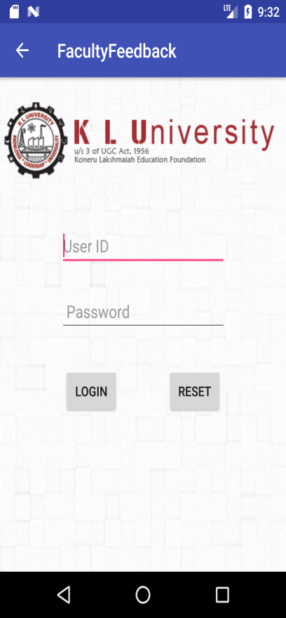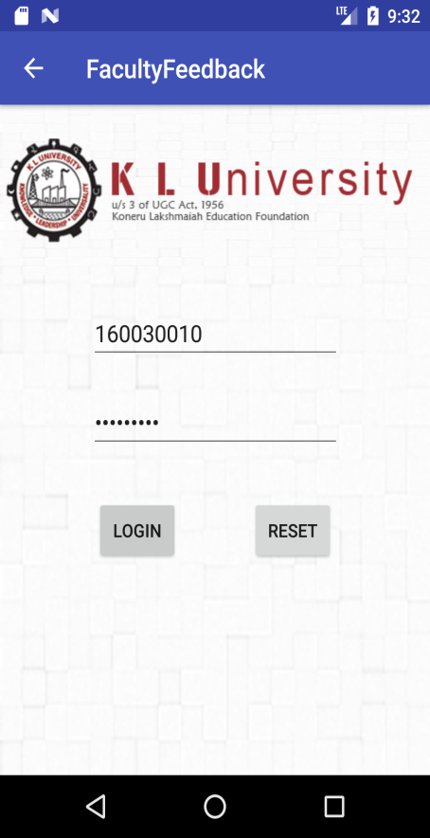

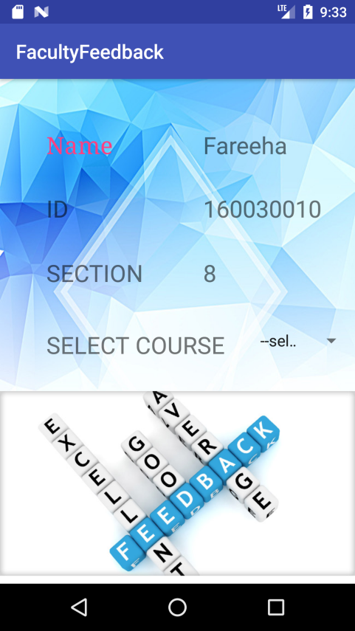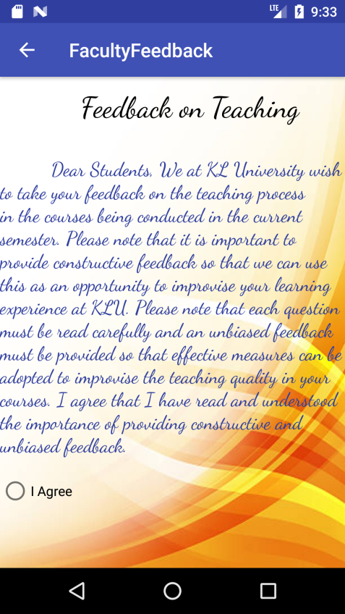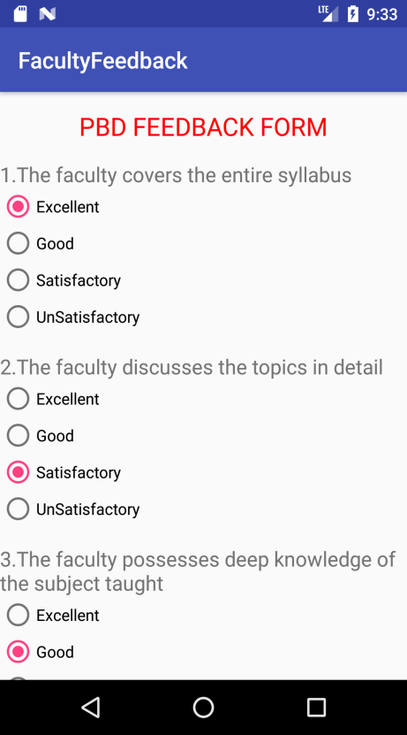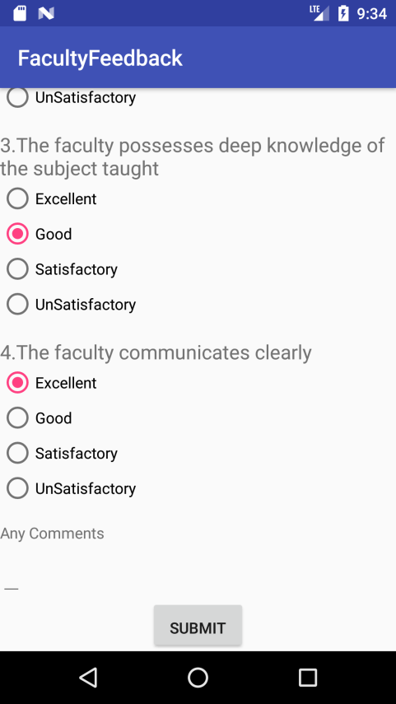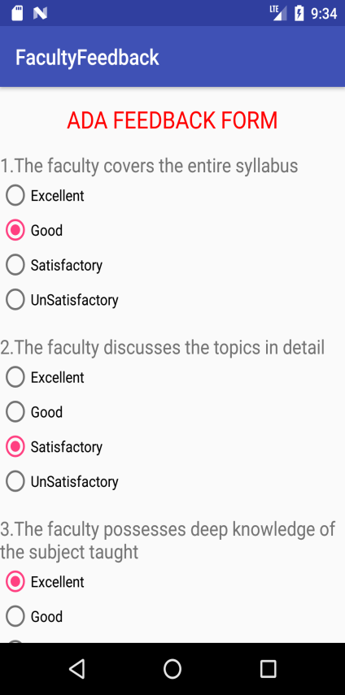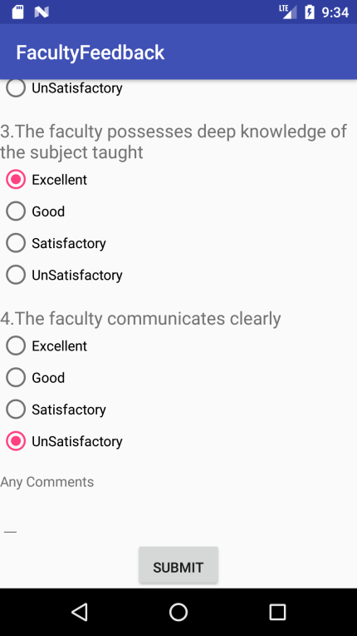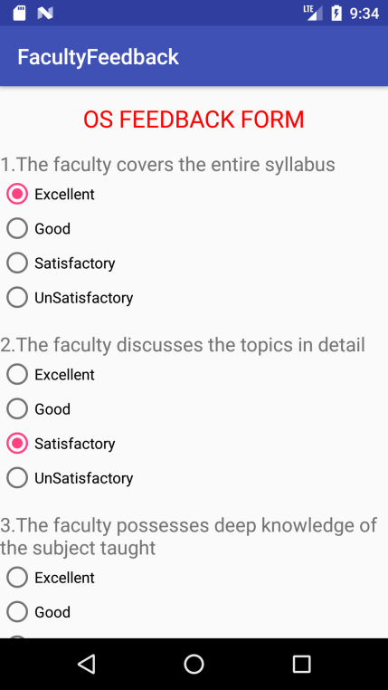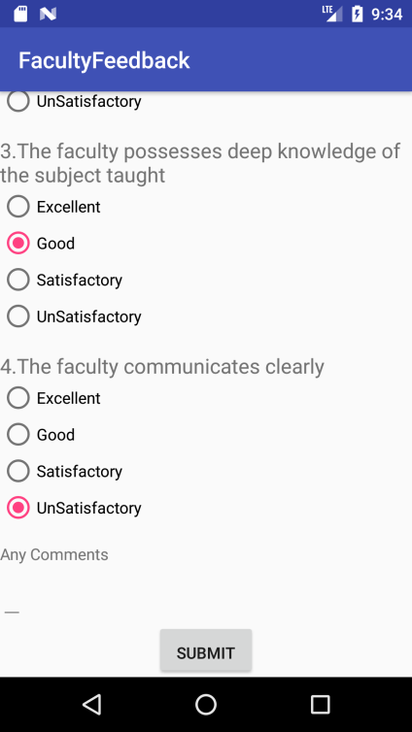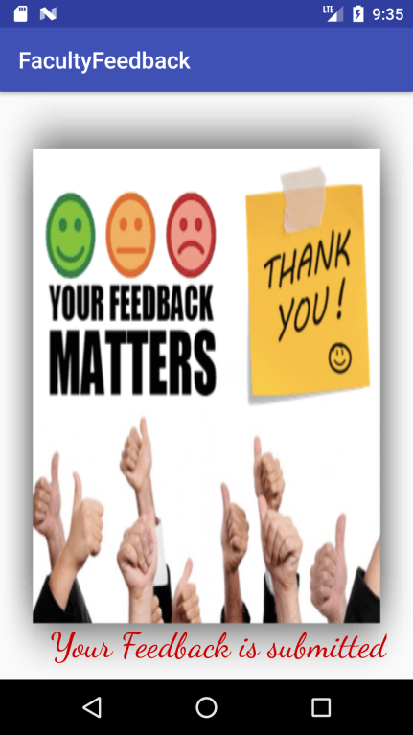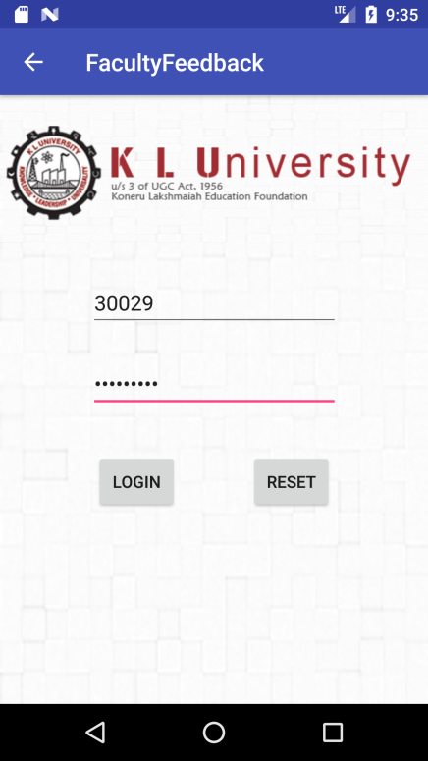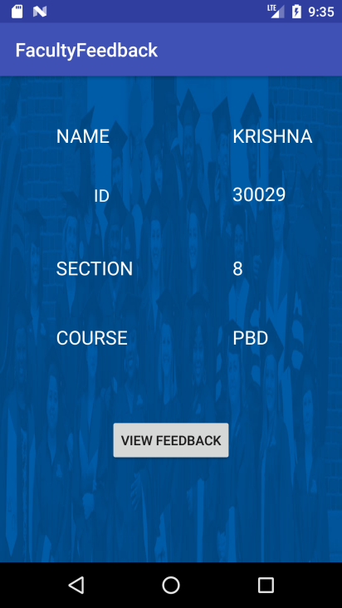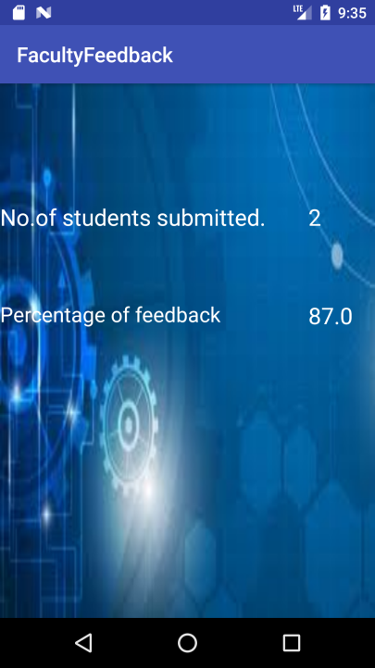

**CONCLUSION:**

The project Faculty feedback in order to reduce maintainining bulk of records of all the student as well as faculty feedback details of who study and teach in an educational institution.Inserting,Retreiving and Updating the feedback details of student are easy when it is compared to the manual feedback and storing.Maintaining the project is also easy which can is easily understandable.Maintaing the details in the database is manageable.

**REFERENCES:**

1.http://tutorialspoint.com/android

2.slideshare.net

3. Text Book: programming cookbook,chryssa aliferi,Alexis Media plus